**Title : Report on E-Waste Generated in the Campus – IIT Bombay**

**1.Introduction**

With the rapid advancement of technology, educational institutions like IIT Bombay have seen a significant increase in electronic waste (e-waste) generation. E-waste consists of discarded electronic devices such as computers, mobile phones, printers, batteries, and other equipment that are no longer usable or outdated. This report explores the amount of e-waste generated at IIT Bombay, its impact, and potential solutions for managing it efficiently and sustainably.

**1. E-Waste Sources at IIT Bombay**

IIT Bombay, being a premier technical institution, relies heavily on advanced technology for its research, administration, and teaching activities. This results in the generation of a considerable amount of e-waste, which primarily comes from the following sources:

* **Computers and Laptops**: Obsolete or malfunctioning desktops, laptops, and servers used in administrative offices, research labs, and student facilities.
* **Mobile Devices**: Old smartphones, tablets, and wearable devices used by students and staff that are frequently upgraded or replaced.
* **Laboratory Equipment**: Research and laboratory instruments that become outdated due to technological advances.
* **Printers and Photocopiers**: Old or damaged printers, copiers, scanners, and related accessories such as cartridges.
* **Batteries and Cables**: Discarded batteries from electronic devices and damaged electrical cables.
* **Other Electronics**: Audio-visual equipment, networking devices, routers, projectors, and calculators.

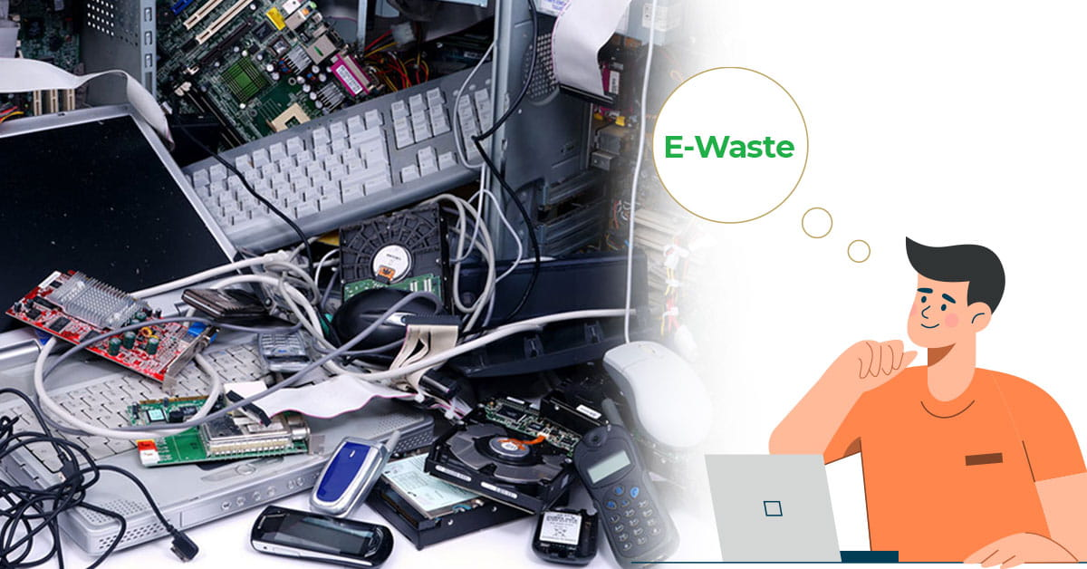

**2. E-Waste Data (from IIT Bombay)**

Based on data gathered from campus authorities, the following e-waste statistics highlight the quantity and types of electronic waste generated annually at IIT Bombay:

* **Computers and Laptops**: Around **300 to 400 units** of old computers and laptops are discarded annually.
* **Mobile Devices**: On average, **500 mobile phones and tablets** are replaced or discarded each year.
* **Printers and Photocopiers**: An estimated **50 to 60 printers and photocopiers** are replaced annually.
* **Batteries and Accessories**: Over **2,000 discarded batteries** and accessories such as cables are generated every year.
* **Other Electronics**: Miscellaneous items such as routers, projectors, and calculators contribute an additional **150 to 200 pieces** to the e-waste total.

**Total Estimated E-Waste Generated Annually: 2 to 3 tons of e-waste per year.**

**3. Impact of E-Waste**

The generation of e-waste at IIT Bombay has the following potential environmental and health impacts:

* **Environmental Impact**:
  + E-waste contains hazardous substances like lead, mercury, cadmium, and brominated flame retardants. When improperly disposed of, these toxins can leach into the soil and water, contaminating the environment.
  + E-waste in landfills can also release harmful gases that contribute to air pollution and global warming.
* **Health Impact**:
  + Exposure to toxic chemicals from improperly handled e-waste can lead to respiratory issues, skin conditions, and even neurological damage, affecting both workers handling the waste and surrounding communities.
* **Resource Waste**: Many valuable materials like gold, silver, and copper are embedded in e-waste. If not recycled properly, these resources are lost, contributing to the depletion of non-renewable resources.

**4. Current E-Waste Management Practices at IIT Bombay**

IIT Bombay has taken several steps to manage and reduce its e-waste footprint:

* **Collection and Segregation**: E-waste is collected from various departments and segregated based on type. Usable parts are salvaged, and obsolete devices are separated for recycling.
* **Recycling**: The institute partners with authorized e-waste recycling companies who are responsible for the proper disposal and recycling of electronic devices.
* **Refurbishment**: Some devices, especially computers and laptops, are refurbished for further use in student projects or for donation to local schools and non-profit organizations.
* **Awareness Programs**: IIT Bombay holds workshops and campaigns to educate students and staff about the importance of responsible e-waste disposal and the benefits of recycling.

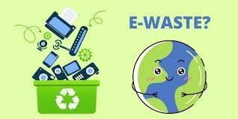

**5. Challenges in E-Waste Management**

Despite the efforts, there are still several challenges faced by IIT Bombay in managing e-waste:

* **Lack of Awareness**: Not all students and staff are fully aware of the proper e-waste disposal procedures, leading to occasional improper disposal.
* **Rapid Technological Advancements**: The fast pace of technological innovation leads to shorter lifecycles of electronic devices, which results in increased e-waste generation.
* **Data Security Concerns**: Proper e-waste recycling involves removing sensitive data from devices before disposal, which is a challenge for many departments.
* **Limited Recycling Facilities**: Although IIT Bombay collaborates with recyclers, India still faces a general shortage of certified e-waste recycling facilities.

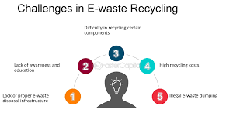

**6. Recommendations for Improving E-Waste Management**

To further improve e-waste management at IIT Bombay, the following recommendations can be implemented:

* **Enhance E-Waste Collection Programs**: Establish easily accessible e-waste collection points across campus, where students and staff can drop off old or unused electronic devices.
* **Promote Refurbishment Programs**: Expand refurbishment initiatives to extend the life of electronic devices and donate them to schools or underprivileged communities.
* **Data Wiping Services**: Provide secure data wiping services to ensure that sensitive information is completely erased before devices are sent for recycling or disposal.
* **Encourage Digital Literacy and Minimalism**: Run campaigns promoting the conscious use of technology, encouraging students and staff to minimize unnecessary upgrades or replacements.
* **Establish Partnerships with More Recyclers**: Strengthen collaborations with authorized e-waste recyclers to ensure all collected e-waste is handled responsibly.

**Conclusion**

IIT Bombay, like many other institutions, generates a considerable amount of e-waste due to its reliance on technology. While steps have been taken to manage this waste responsibly, there is room for improvement, particularly in the areas of awareness, data security, and collection efficiency. With stronger waste management practices and more widespread participation from the campus community, IIT Bombay can significantly reduce its e-waste footprint, contributing to a healthier environment and more sustainable resource use.

**Recommendations**

To manage the growing e-waste problem on campus, the following recommendations are proposed:

* **Awareness Campaigns:** Organize campus-wide campaigns to educate students and staff on the dangers of e-waste and the importance of proper disposal.
* **Improved Recycling Infrastructure:** Install more e-waste collection bins in easily accessible areas across the campus and collaborate with certified e-waste recyclers.
* **Buy-Back and Donation Programs:** Encourage departments to participate in buy-back programs or donate outdated but functional equipment to schools or non-profit organizations.
* **Reduce, Reuse, and Recycle:** Promote the principle of reducing e-waste by extending the life of electronic devices, encouraging the reuse of components, and prioritizing recycling over disposal.

